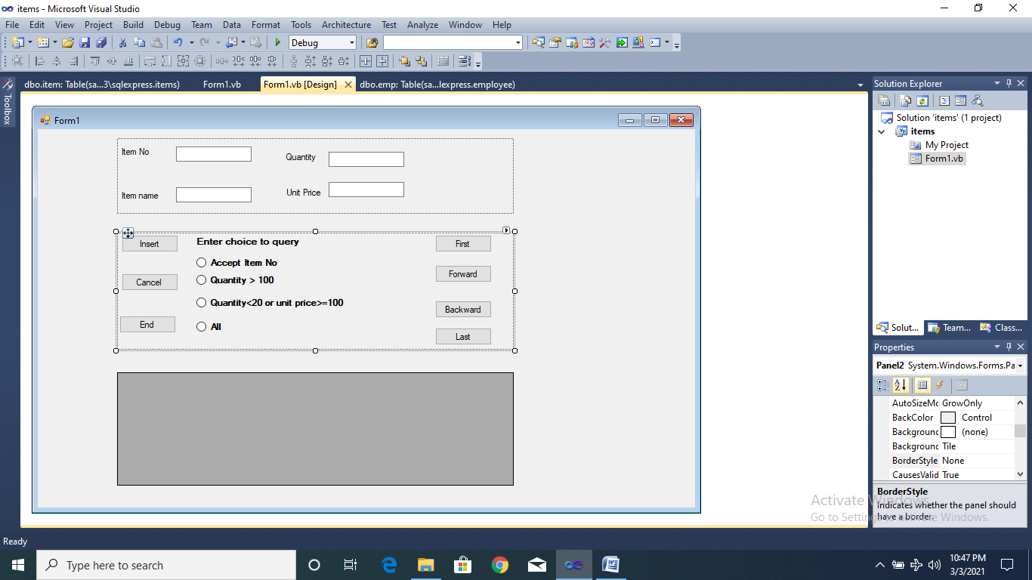

Table Name: item

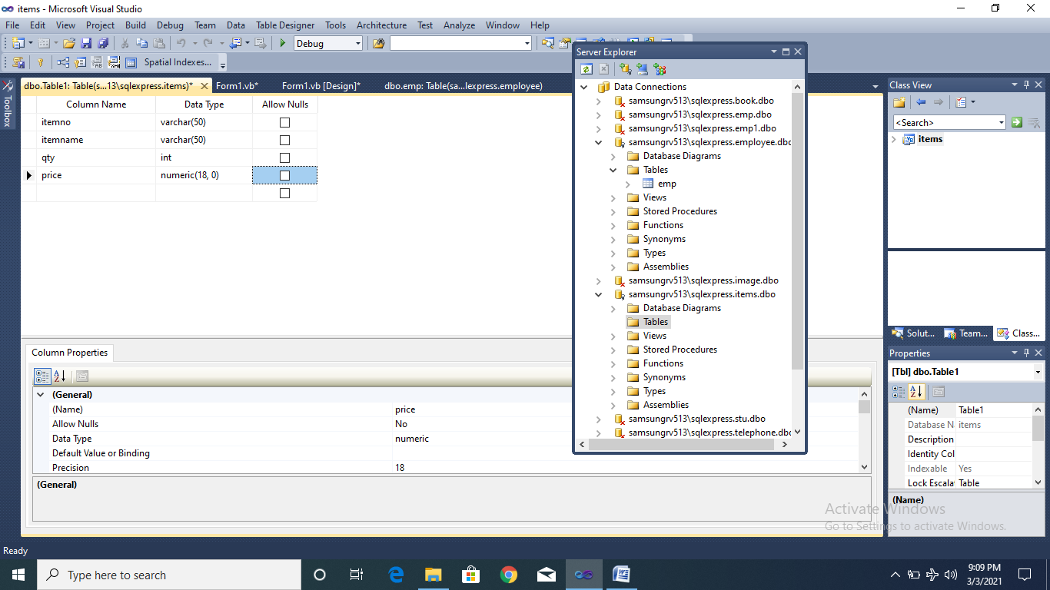

Imports System.Data.SqlClient

Module module1

Public con As New SqlConnection

Public cmd As New SqlCommand

Public Sub connect()

con.ConnectionString = "Data Source=SAMSUNGRV513\SQLEXPRESS;Initial Catalog=items;Integrated Security=True;Pooling=False"

con.Open()

cmd.Connection = con

End Sub

End Module

Public Class Form1

Dim adp As SqlDataAdapter

Dim ds As DataSet

Dim cmdstr As String

Public Sub displaygrid()

Dim rec As Integer

cmd = New SqlCommand(cmdstr, con)

adp = New SqlDataAdapter(cmd)

ds = New DataSet

rec = adp.Fill(ds, "item")

If rec = 0 Then

MsgBox("This item is not present in the database")

End If

DataGridView1.DataMember = "item"

DataGridView1.DataSource = ds

TextBox1.Text = ""

TextBox2.Text = ""

TextBox3.Text = ""

TextBox4.Text = ""

End Sub

Private Sub btnend_Click(ByVal sender As System.Object, ByVal e As System.EventArgs) Handles btnend.Click

End

End Sub

Private Sub Form1_Load(ByVal sender As System.Object, ByVal e As System.EventArgs) Handles MyBase.Load

DataGridView1.Enabled = False

End Sub

Private Sub btninsert_Click(ByVal sender As System.Object, ByVal e As System.EventArgs) Handles btninsert.Click

If Val(TextBox1.Text) <= 0 Or Val(TextBox4.Text) <= 0 Or Val(TextBox4.Text) <= 0 Then

MsgBox("Please enter nonzero and positive numbers only")

Exit Sub

End If

connect()

cmd.CommandText = "insert into item(itemno,itemname,qty,price)values('" & TextBox1.Text & "','" & TextBox2.Text & "','" & TextBox3.Text & "','" & TextBox4.Text & "')"

cmd.ExecuteNonQuery()

MsgBox("Record inserted")

con.Close()

End Sub

Private Sub btncancel_Click(ByVal sender As System.Object, ByVal e As System.EventArgs) Handles btncancel.Click

TextBox1.Text = ""

TextBox2.Text = ""

TextBox3.Text = ""

TextBox4.Text = ""

End Sub

Private Sub RadioButton1_Click(ByVal sender As System.Object, ByVal e As System.EventArgs) Handles RadioButton1.Click

Dim itemnum As String

itemnum = InputBox("Enter item number to be searched")

connect()

cmdstr = "select * from item where itemno=" & itemnum

displaygrid()

con.Close()

End Sub

Private Sub RadioButton2_Click(ByVal sender As System.Object, ByVal e As System.EventArgs) Handles RadioButton2.Click

connect()

cmdstr = "select * from item where qty > 100"

displaygrid()

con.Close()

End Sub

Private Sub RadioButton3_Click(ByVal sender As System.Object, ByVal e As System.EventArgs) Handles RadioButton3.Click

connect()

cmdstr = "select * from item where qty<20 or price>=100"

displaygrid()

con.Close()

End Sub

Private Sub RadioButton4_Click(ByVal sender As System.Object, ByVal e As System.EventArgs) Handles RadioButton4.Click

connect()

cmdstr = "select * from item"

displaygrid()

con.Close()

End Sub

Private Sub btnfirst_Click(ByVal sender As System.Object, ByVal e As System.EventArgs) Handles btnfirst.Click

BindingContext(ds, "item").Position = 0

End Sub

Private Sub btnfor_Click(ByVal sender As System.Object, ByVal e As System.EventArgs) Handles btnfor.Click

If BindingContext(ds, "item").Position = BindingContext(ds, "item").Count - 1 Then

MsgBox("You are already in last record. Can't move further")

Else

BindingContext(ds, "item").Position = BindingContext(ds, "item").Position + 1

End If

End Sub

Private Sub btnback_Click(ByVal sender As System.Object, ByVal e As System.EventArgs) Handles btnback.Click

If BindingContext(ds, "item").Position = 0 Then

MsgBox("You are already in first record!")

Else

BindingContext(ds, "item").Position = BindingContext(ds, "item").Position - 1

End If

End Sub

Private Sub btnlast_Click(ByVal sender As System.Object, ByVal e As System.EventArgs) Handles btnlast.Click

BindingContext(ds, "item").Position = BindingContext(ds, "item").Count - 1

End Sub

End Class